CTM-I Use Case

Class Information

Version 0.1

Use Case Name | Class Information
Actor | Market Ops, Operations, App Support
Pre-conditions /Assumptions | User has Browser and is aware of the http path to the application.  User has successfully logged into the CTM-I application.  User has the right role to see the menu options.
Post Conditions | None
Screenshot | 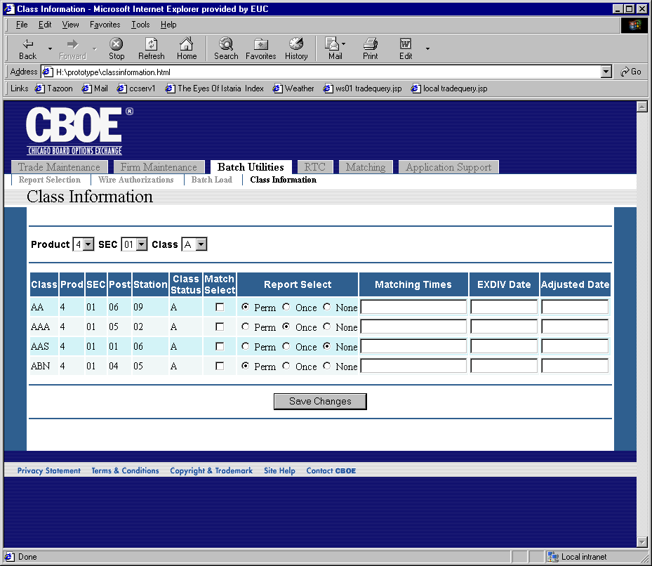
Flow of Events | - User will select “Class Information” from the menu  - Class Information screen will appear  - Three criteria fields will be on the screen  - Product Type – Lists all valid Product Types  - Security Type – Lists all valid Security Types  - First Letter of Class Symbol – values A..Z  - The user will select the criteria to narrow down the class list that is going to be displayed.  - The user presses the “Find Classes” button to get a list of classes for the criteria.  - The request is sent to CTM-R to get the list of classes.  - The list of classes from CTM-R is listed on the screen.  - All classes retrieved will be displayed. There will be no paging.  - The screen will display with the following fields in a row format.  - Class Symbol  - Product  - Security Type  - Post  - Station  - Class Status  - Match Select  - Report Select  - Matching Times  - EXDIV Date  - Adjusted Date  - Product, Security Type, Class Symbol, Post, Station and Class Status are read-only fields and do not allow edit.  - Match Select field will display the current value and allow the user to change the value. The allowed values for Match Select are selected or not selected.  - Report Select field will display the current value and allow the user to change the value. The allowed values for Report select are Permanent, Once and none selected.  - Matching times field will display the current value and allow the user to change the value.  - EXDIV date field will display the current value and allow the user to change the value.  - Adjusted date field will display the current value and allow the user to change the value.  - The user clicks “Save Changes” to save the changes made. The changes will be sent to CTM-R to be processed.  - The screen will refresh with the results from CTM-R.
Alternative Path | 1.1 List Alternative Flows Here.

